Shutterstock

Definition
# Source: ScreenShots Source: Provided by: [Persons Table -> ID Column: 1, Name_En Column: Motasem Essam] -> Tool: [Lightshot Program] -> From [Site: https://www.alamy.com/] on [12/24/2025]
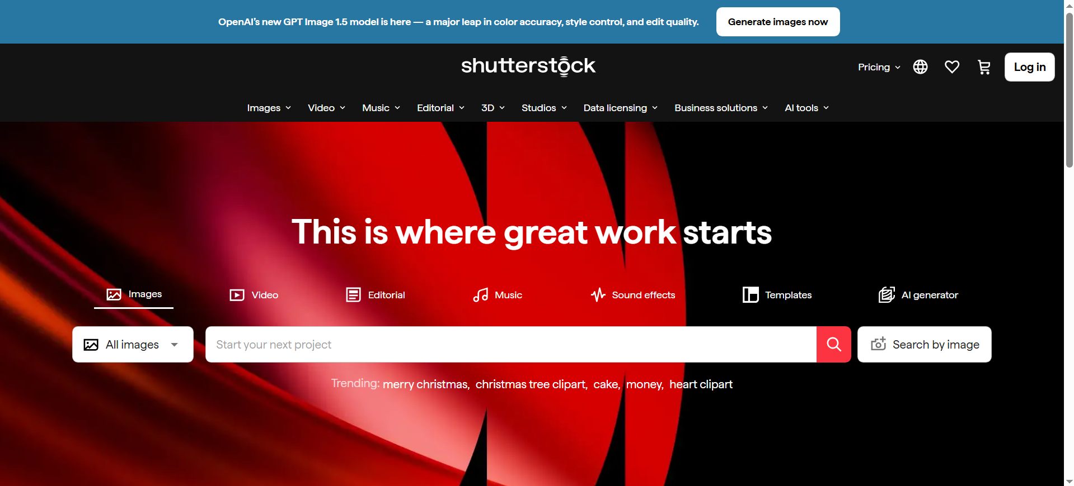
# Source: AI Source: Provided by: [Data Path: Persons Table -> ID Column: 1, Name_En Column: Motasem Essam] -> From: [ChatGPT] on [12/24/2025]
Shutterstock is a commercial stock media platform that provides licensed digital assets for creative and professional use.

In simple terms
# Source: AI Source: Provided by: [Data Path: Persons Table -> ID Column: 1, Name_En Column: Motasem Essam] -> From: [ChatGPT] on [12/24/2025]
It’s an online marketplace where individuals and businesses can buy licenses to use ready-made creative content instead of creating everything from scratch.

What Shutterstock provides
# Source: AI Source: Provided by: [Data Path: Persons Table -> ID Column: 1, Name_En Column: Motasem Essam] -> From: [ChatGPT] on [12/24/2025]
- Stock photos (the most common)
- Illustrations & vectors
- Videos & footage
- Music & sound effects
- Templates & 3D assets (in some plans)

What it’s used for
# Source: AI Source: Provided by: [Data Path: Persons Table -> ID Column: 1, Name_En Column: Motasem Essam] -> From: [ChatGPT] on [12/24/2025]
- Websites and blogs
- Social media posts
- Marketing and advertising materials
- Presentations and documents
- App and UI design
- Print media (posters, flyers, books, etc.)

How it works (high level)
# Source: AI Source: Provided by: [Data Path: Persons Table -> ID Column: 1, Name_En Column: Motasem Essam] -> From: [ChatGPT] on [12/24/2025]
- Creators upload content to Shutterstock.
- Shutterstock reviews and catalogs it.
- Users purchase a license (subscription or single download).
- The license grants specific usage rights (not ownership).

Key points to know
# Source: AI Source: Provided by: [Data Path: Persons Table -> ID Column: 1, Name_En Column: Motasem Essam] -> From: [ChatGPT] on [12/24/2025]
- Paid service (not free stock media)
- Content is licensed, not owned
- Usage is governed by license terms (standard vs. enhanced)
- Attribution is usually not required, but license compliance is

